Prueba Tecnica – UniComer

Jhener García

Software Specification:

* Java: 11
* Spring Boot: 2.7.6
* OpenAPI: 3.0
* Database: H2 file based.

Swagger files can be found in:

Repository as json and yaml files:

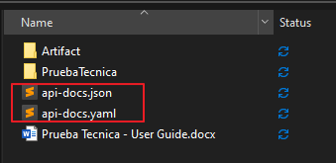

Or at the following urls:

<http://localhost:8080/api-docs.yaml>

<http://localhost:8080/v3/api-docs>

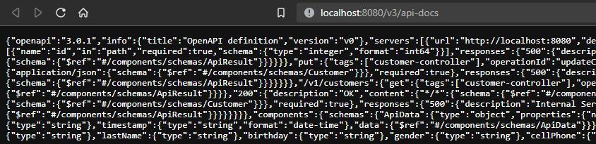

Swagger UI

<http://localhost:8080/swagger-ui/index.html#/>

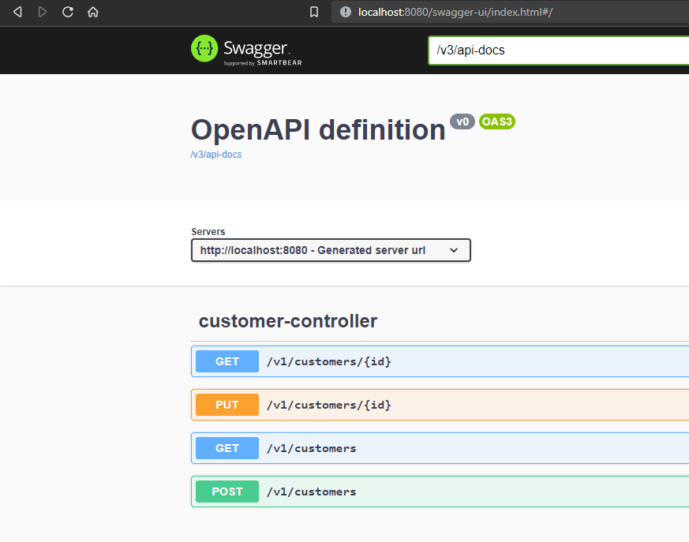

Generate jar file:

gradlew clean build

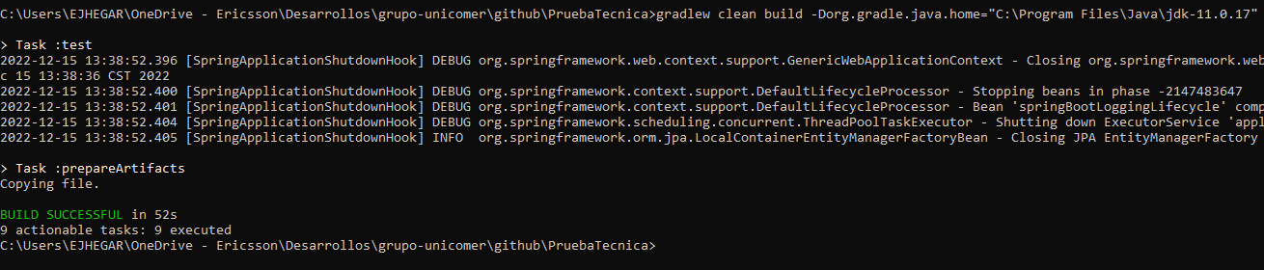

It generates a “Artifact” folder with all necessary for the jar execution:

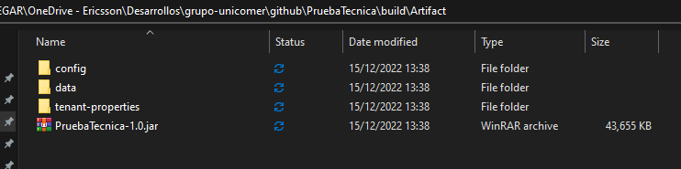

Config folder:

* Application Configuration
* Logback configuration

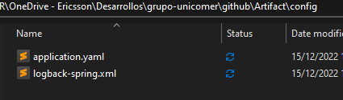

Data Folder:

* All 3 databases for each customer

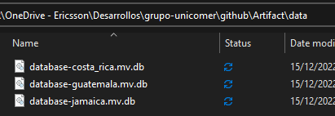

Tenant Properties Folder:

* Configuration for each database

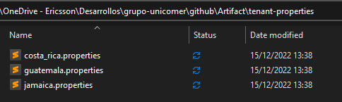

Execute jar file:

java -jar PruebaTecnica-1.0.jar

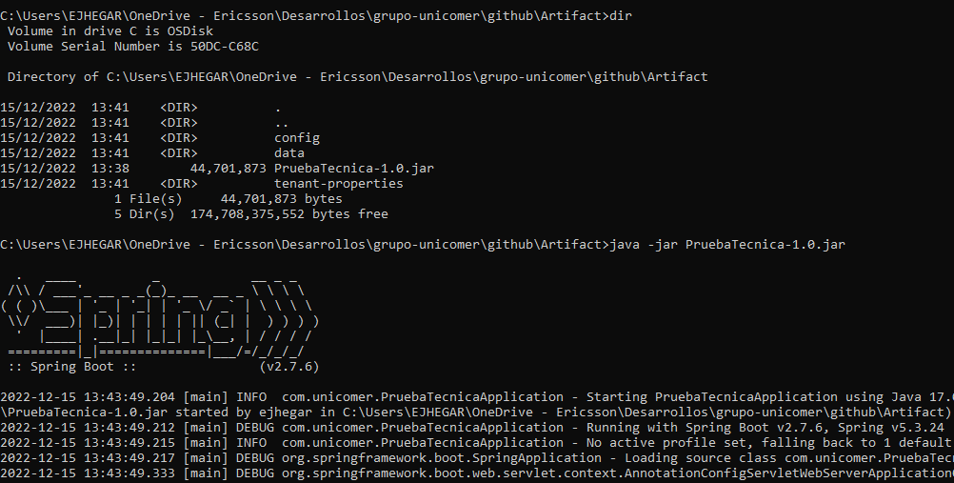

Logs are generated in log folder:

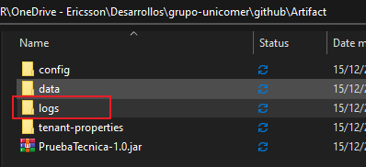

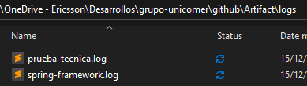

Execute GET request with header: Country = guatemala:

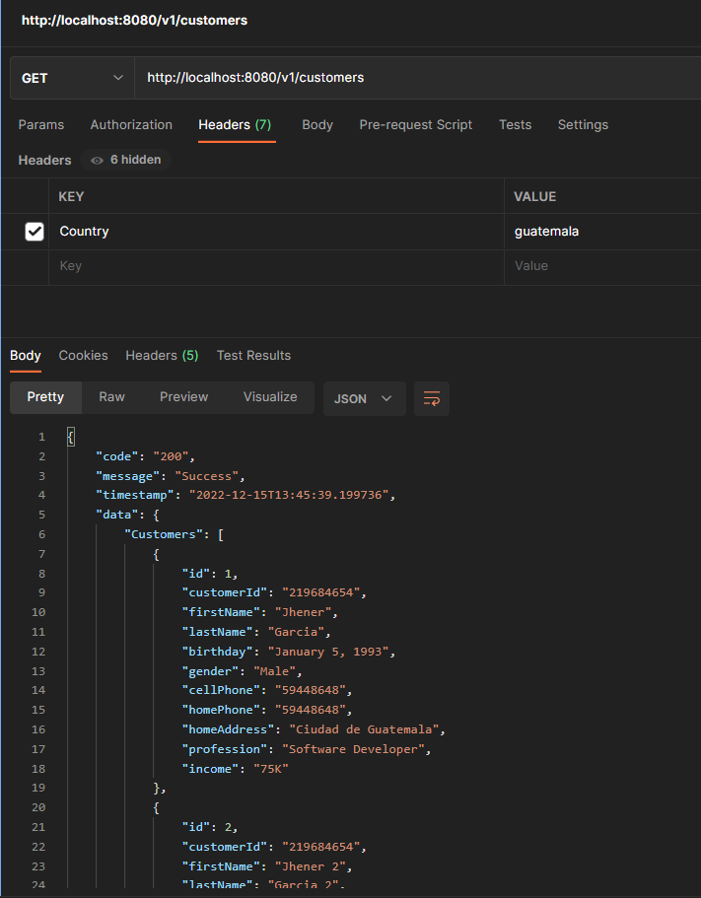

Jamaica:

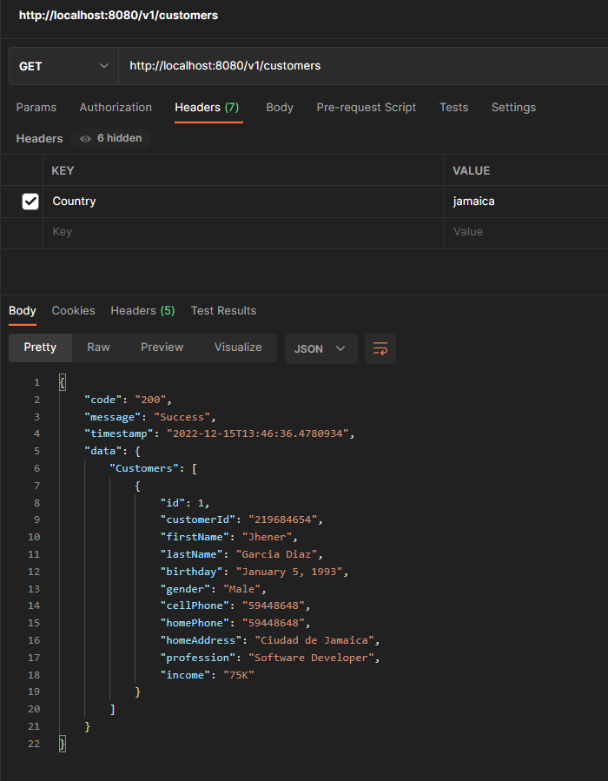

Costa Rica:

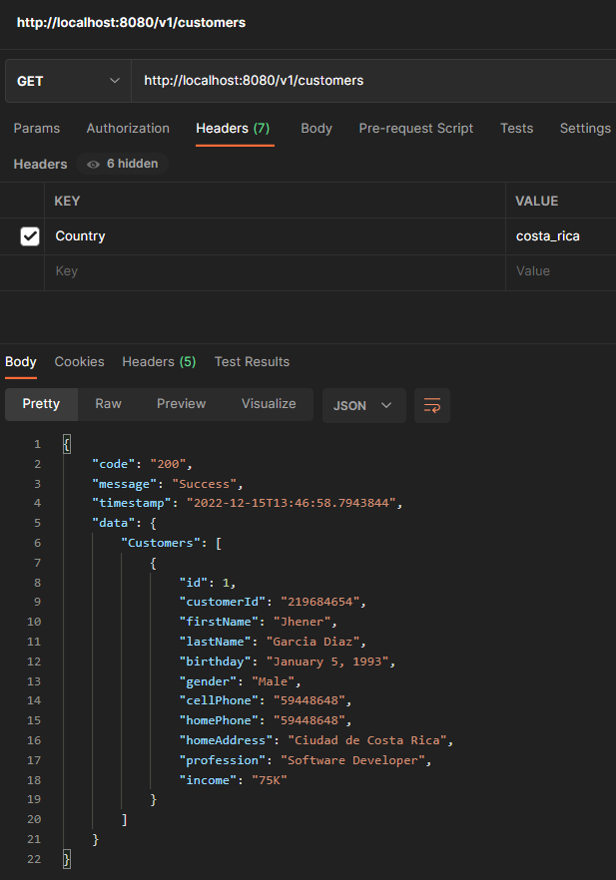

GET Request, find by id:

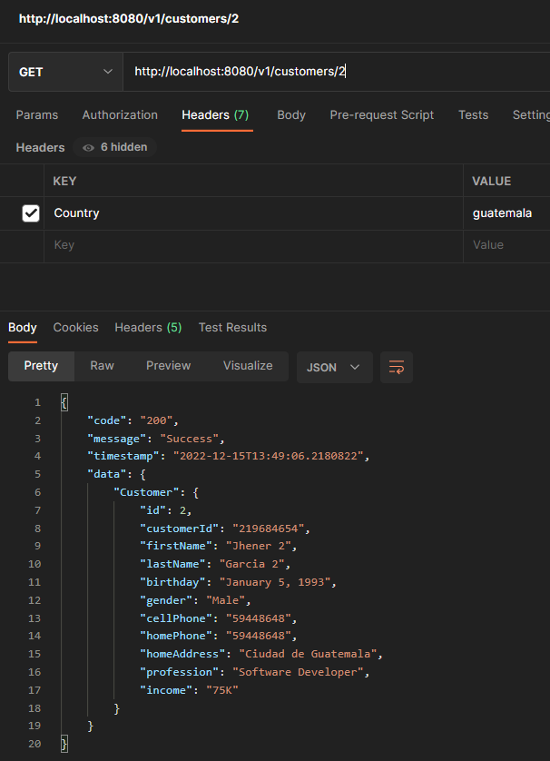

POST Request:

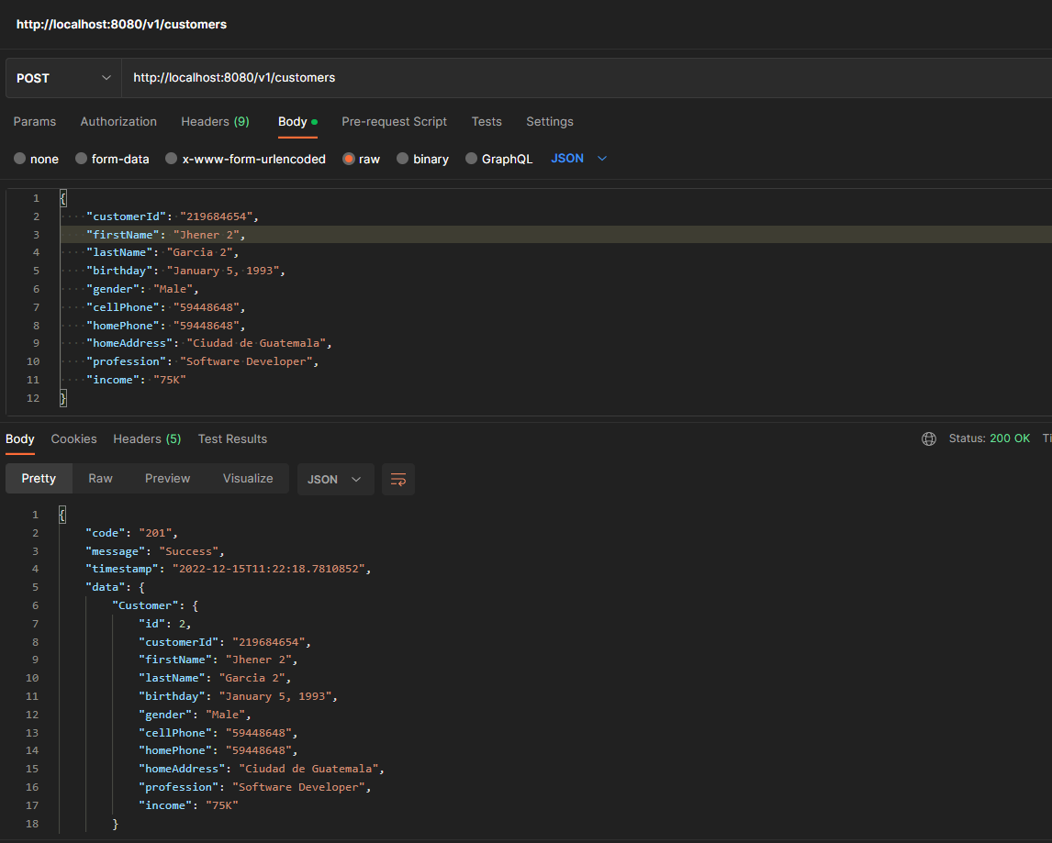

With header Country=guatemala

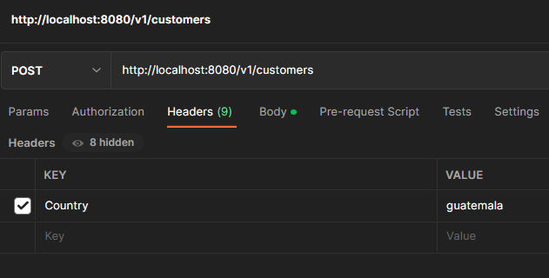

PUT Request:

